- Market Efficiency Learning Objectives
  - Discuss the concept of market efficiency
  - Explain the factors affecting a market’s efficiency.
  - Distinguish between market value and intrinsic value.
  - Compare and contrast weak-form, semistrong-form, and strong- form market efficiency.
  - Consider the evidence on market efficiency
  - What are the implications of the evidence

N.B. Of all the concepts that you will discuss in this course, I regard the
EMH as being the most influential

- Market efficiency requires that security prices react immediately in an unbiased way to the receipt of new information
- The two important characteristics:
  - Immediately
  - Unbiased which means that the current price is always the best estimate of the true value of the security
- This does not mean that securities (or markets) do not become mispriced but rather that there is no way to consistently use available information to identify these mispricings

- The EMH hypothesis relates to information efficiency
  - The market assess information and “correctly” incorporates this into
market prices
- Allocative efficiency means that the a nation’s scarce capital
resources are allocated to their best possible use
  - This is the role of capital markets
  - The EMH is a necessary but not a sufficient condition for allocative
efficiency

- Active management is a fruitless exercise?
  - YES but . . . .
  - The conundrum
- Prices are always right?
  - WRONG!
- Portfolio construction is also a fruitless exercise
  - NOT true - in fact totally the opposite

- Market value is the value placed on the firm by the market
- Intrinsic value is what the firm is actually worth
- Assuming an efficient market, the market value is the best estimate
that we have of the intrinsic value
- We never . . never . . never ever ever know a firm’s intrinsic value
  - We can never have concrete evidence on the efficiency of markets, either at the current point in time , or even looking back to past periods
  - Hence any evidence on market efficiency has to be circumstantial

Strong form: All information
Semi-strong form:
All publicly available information
Weak form: Prices and volume

One can address the question of whether a market is efficient at two levels:
- Does it behave as if it is efficient?
  - Evaluating this involves conducting empirical tests to see if the market behaves as if it is efficient
- What reason does one have to believe that the market would be
efficient?
  - Evaluating this involves seeing if the conditions actually exist that are required for the market to be efficient
We will spend the next little while addressing these two questions, with more time spent on the second question

- Large volume of studies provide anomalous evidence on market efficiency:
  - The evidence on price (and earnings momentum) suggest that there are identifiable trends in security prices
  - The evidence of value investing suggest that one can identify stocks that have overshot fair value in both directions
  - There is a large amount of evidence (some of which we shall see in this session) to suggest that markets are slow to react to the release of information
- The debate continues as to whether markets are or are not efficient
while the amount of anomalous evidence just keeps growing

- Free flow of information to the market
- Market is composed of rational investors all competing against each other with the objective of maximising wealth
- No market imperfections (taxes, transaction costs, etc.) or limitations on trading
We will consider each of these conditions in turn, with the greatest
concentration on the first two.

In considering this condition, we will concentrate on the following two issues:
- Whether the market acts as though it knows all the information about a firm (asymmetric information)
- Whether management attempts to “manipulate” the market using
information flows and whether the market can be fooled

- What is it? A situation where one party has information not available to the other
- In our case the informed are presumed to be “insiders’ to the
company and the uninformed are external investors
- Implications - The uninformed will try and glean the information from actions taken by the informed (i.e. signals)
- In our case, parties external to a company interpret the implications of corporate announcements in terms of what it suggests about the future earnings capacity of the company

Announcement | Paper | Short-term | Medium Term
New share issues | Asquith and Mullins (1986) | -2.57% (1 day) | -6% (48 9 days)
 | Loughran & Ritter (1995) |  | -8%pa (5 years)
 | Spiess and Affleck (1995) |  | -30% (5 years)
 | Lee (1997) | -3% (2 days)
Mergers | Taylor (1987) | -1.47% (S) +0.24% (C)  (I day)
 | Loughran & Vijh (1997) |  | -25% (S) +61.7% (C) (5 yrs)
Stock repurchases | Ikenberry et al. (1995) | +3.54% (5 days) | +12.1% (4 years)

- The market is taking the announcement as a signal as to management’s wider
expectations re profitability
- The underreaction is evident

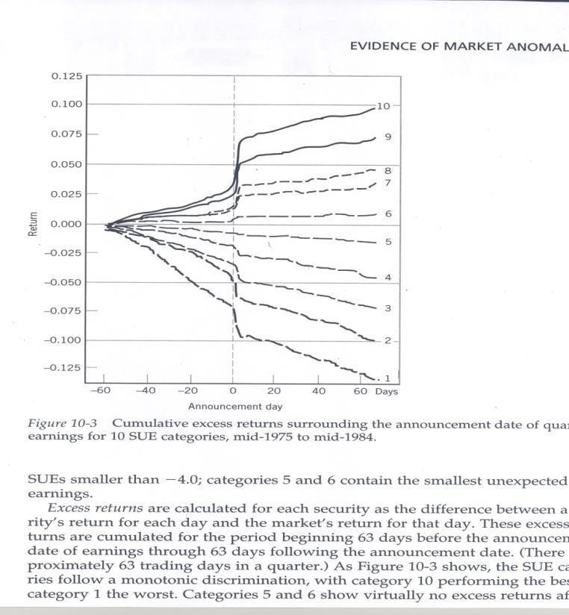
- The market places great weight on earnings announcements or more particularly earnings surprise
- There is a significant reaction to the release of earnings information but then a further sizeable adjustment over an extended post-announcement period

- The evidence clearly supports that insiders profit from their trading.
- These profits are largely associated with their purchasing as their selling is often driven by other than profit motives
- Insiders are largely value investors being good at predicting when their
firm’s share price has fallen too low

- It appears clear that the market reacts to corporate announcements driven by the implications that the announcement has for the future earning power of the firm and so its valuation
- There seems to be a slow reaction in the market to new information with the price adjustments sometimes extending out as much as five years and more
- We will see subsequently that this suggests a possible conundrum
where the market both under-reacts and over-reacts to information

- The presumption is that management will only go to the trouble of manipulating information if the manipulation will fool markets and it has some benefit to themselves
- As we will see later, it would appear that manipulation is a phenomenon of the last 30 years
- The following material develops the rationale for why management might want to manipulate information and then provides evidence on the implications of them so doing

- The question is whether management can manipulate the share price via information release and whether they can directly benefit from this manipulation
- There is clear information to suggest that “bad” news has a much greater negative impact on share price than the positive impact from the release of “good” news
  - Consider a firm that has a good year followed by a bad year
  - GAAP gives it the flexibility of reporting two average years and so end up with a higher stock price than it would without manipulating its information release
- Can and do management directly benefit from a higher stock price
  - The evidence suggest that they can most certainly benefit via stock options

- Although it is not possible to manage earnings in the long term, there is clear evidence that the management of many firms attempt to do so in the short term
- Further we will see that there is clear evidence that that the market is fooled by this manipulation - similar credibility is given to accounting created earnings as to cash earnings

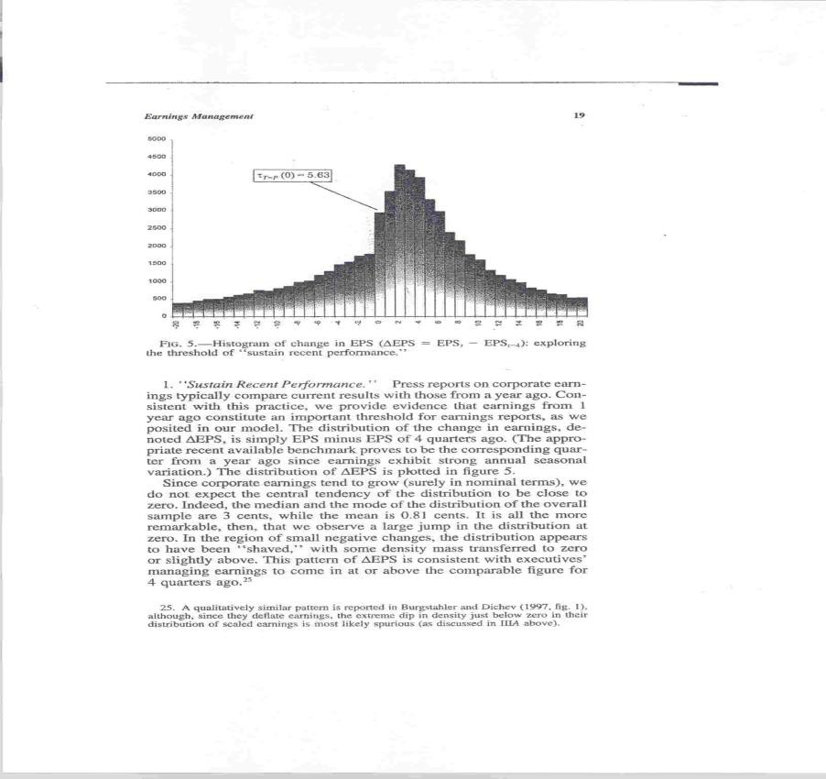
- Earnings would appear to be managed to meet the following thresholds:
  - positive profits
  - previous profit level
  - Analyst’s expectations
- Future performance of those that just meet thresholds is worse than a random control group

- Responses to the statement: “Meeting earnings benchmarks helps …”
based on a survey of 401 financial executives.

build credibility with capital market maintain or increase our stock price external reputation of management
convey future growth prospects to investors
reduce stock price volatility assures stakeholders business is stable employees achieve bonuses
achieve desired credit rating avoid violating debt-covenants

0% 10% 20% 30% 40% 50% 60% 70% 80%
Percent agree or strongly agree

90% 100
%

- Responses to the statement: “Failing to meet benchmarks…” based
on a survey of 401 financial executives.
- Cockroach Theory:
  - “If you see one cockroach, you immediately assume there are hundreds behind the walls, even though you have no proof that this is the case”
creates uncertainty about our future prospects outsiders think there are previously unknown problems have to spend time explaining why we missed increases scrutiny of all aspects of earnings releases
outsiders might think firm lacks flexibility increases the possibility of lawsuits
0% 10% 20% 30% 40% 50% 60% 70% 80% 90%

- It is common practice for management to manipulate both earnings expectations and also reported earnings (even at the expense of taking decisions that reduce the firm’s value)
- Is the market fooled by such practices?
  - Sloan: The market values earnings created by accounting manipulation equally to those created by cash transactions
  - Bartov et al: A change in earnings forecast has a much smaller
impact on prices than does an earnings surprise

- The second condition for market efficiency is competition upon rational investors all utilising the available information to identify mispriced stocks with the view of pursuing an investment strategy with the objective of maximising their wealth.
- There are two potential causes for this to breakdown:
  - Investors are not rational in an economic sense (behavioural
finance)
  - many investment processes only use a (small) subset of the available information
- We will only look at the second of these in this session as the session on
behavioural finance will address the first cause

- Fundamental investing where investors attempted to use all available information to best value a company was the dominant form of investing 50 years ago.
- Since then there has been the emergence of other styles of investment, many of which completely ignore fundamental information (e.g index and momentum investors), to a stage where information-based investors are in a minority
- The question we address is whether the existence of these other styles has any impact on the price formation process?
  - To address this question we created artificial markets consisting of
investors using several styles and observed their impact on pricing

Equal proportion: Fundamental, Momentum & Index investors

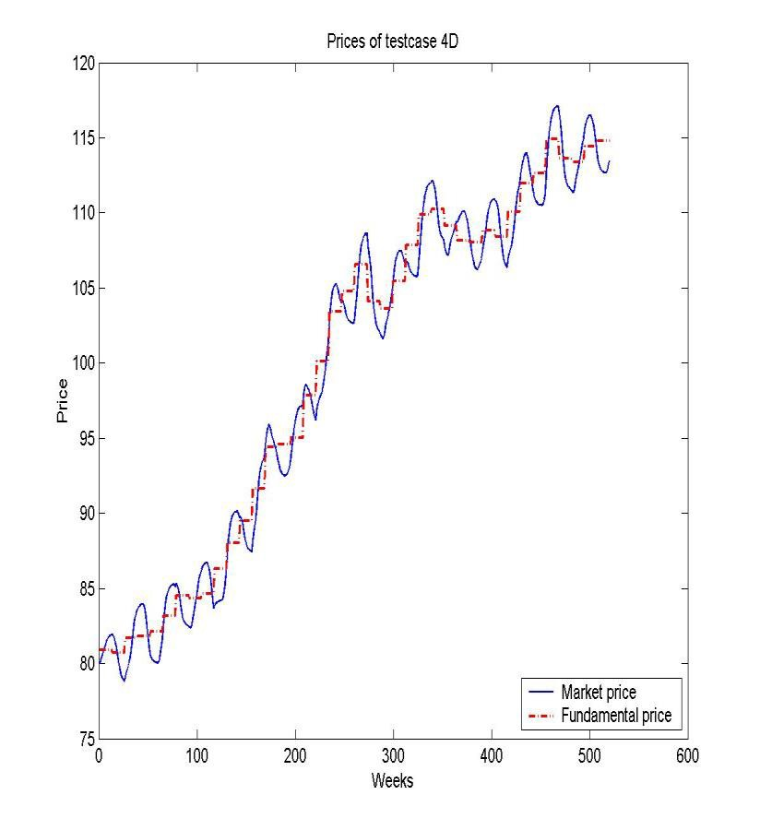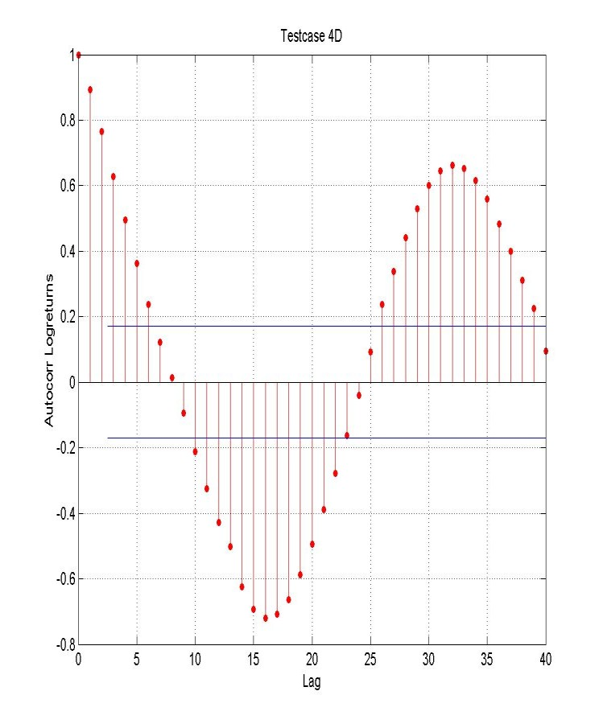Investment Man 25
agement Analyst Certificate (IMAC) | Efficient Market Hypothesis

- Confirmation that a market largely composed of fundamental investors will result in a high level of market efficiency in that prices will quickly react to the release of new information
- Prices in markets where momentum and index investors are in a majority will be slow to react to information
  - Index investors will progressively slow this reaction to new information as they come to represent an increasing
proportion of the market
  - Momentum investors (similar to index investors) will slow the market reaction to new information but will invest when a drift in prices becomes established, which eventually leads to an overreaction as they will ignore turning points in fundamentals
- Equally markets where momentum and index investors are in a majority will result in prices that overshot fair value
  - When new information becomes available that is in conflict with the expectations built into prices, it will be ignored by the index investors while the momentum investor still be trading on the trend and only the fundamental investors will be influenced by the new information
  - As a consequence, there will be a tussle between the momentum investors and the fundamental investors and so the unexpected information will have little or no impact on pricing and as a consequence prices will overshoot fair value (in either direction)
- Further, there is no reason to assume a change in the constituents of markets and so the pricing behaviour that has been outlined is unlikely to disappear
  - Both momentum and index investing are sensible styles to follow

- In a world with transaction cost, taxes etc., there will be a permanent wedge driven between actual pricing and fundamental value
- As an example, if someone has identified that a stock is worth $1.05 and its current price is $1.00, they will not trade if it will cost them more than 5 cents per share
- Many have suggested that it is transaction costs which explain many of the anomalous evidence from the empirical studies but in general they are just too large
- In addition, restrictions on trading such as those applied to short-selling will inhibit trading and so lead to anomalous pricing

- The empirical evidence and the failure of many of the conditions upon which efficient pricing depends suggests markets will not be efficient
- The conclusions that one then draws is that opportunities exist within markets to identify mispriced securities
- The insights that we have gained is that securities underreact to information in the short-term but overreact in the long-term thus enabling an investor to benefit from both the trend and mean- reversion in the price path of a typical stock
  - Contrast this with the conclusions drawn in the text
- Is the existence of inefficient market sufficient to justify the use of
active managers?
  - NO: Inefficient markets are a necessary but not a sufficient condition for justifying the use/existence of active managers!!!
  - WHY?

- There would appear to be sufficient mispricings in even the most developed equity markets to offer opportunities to those who are prepared to exploit them in a very disciplined fashion
- These opportunities can be exploited applying a range of investment styles:
  - Fundamental investing?
  - Momentum investing?
  - Contrarian investing?
- Then why do not managers display significant outperformance?

- One possible answer is that they cannot!
  - As Sharpe pointed out, investing is a zero-sum game and so managers as a group have to get the average return
  - Even if this is true, then why cannot managers win at the expense of the less
sophisticated investors?
    - Who are the losers as even a random investor should suspect the average return
    - What about the overseas investor?
- Another possible explanation is that managers are just no good
  - Stock selection?
    - The evidence is that managers can add value by stock selection (even if this
only applies to a limited number of stocks)
  - Asset allocation?
    - Little evidence that managers have any special capabilities in this area

- So if manages have some skills, why do we not see higher returns?
  - The managers take all of the surplus? (Berk and Green)
  - The managers are really not trying to outperform
    - Agency costs (Bird et al.)
    - Managers are driven to “glamour” stocks
  - Managers over diversify
    - The typical manager can identify less than 20 mispriced stocks
  - Any other reasons?
- On balance the evidence suggests that active managers may even contribute to the mispricing in markets
  - Philippon showed that even with the growth in professional managers and the significant reduction in information costs, that there had been no perceivable reduction in inefficiencies in markets

What about analysts?

- Are sell-side analysts driven by the accuracy of their forecasts or the impact that they can have on the profitability of their employer?
  - Analysts strongly favour large, well performing glamour stocks which are favoured by the market
  - Once one takes account of these biases, analysts display little ability to add value
- Buy side analysts?
- Little evidence to suggest that analysts contribute to efficient markets

Take out(s)

- Getting their mind around the EMH is extremely important for anyone who manages funds or who provides advice on the management of funds
- The evidence seems to suggest that both individual securities and asset classes can be mispriced for extended periods of time.
- What are the implications?

